***FLOWCHART:***

• Flowchart A graphical representation of the logic for the problem solving.

• The purpose of the flowchart is making the logic of the program in a visual

representation.

• Flowcharts is a diagram made up of boxes, diamonds, and other shapes, connected

by arrows.

• Each shape represents a step-in process and arrows show the order in which they

occur.

|  |  |
| --- | --- |
|  | OVAL – TERMINALS |
|  | PARALLELOGRAM – INPUT, OUTPUT |
|  | RECTANGLE – PROCESS |
|  | DIAMOND – DECISION MAKING |
| 26 Simbol-Simbol Flowchart Beserta Fungsinya Lengkap – Blog Mamikos | ARROW – FLOW LINES |
|  | TO REPRESENT A FUNCTION |
|  | CIRCLE – CONNECTOR |

***TOOLS USED TO DRAW FLOWCHART:***

**1. Smart Draw –** A good tool to draw and understand but can’t save the file in system it

can be used for free up to 7 days after that we must pay to use it.

**2. Canva –** A user-friendly tool which allows the user to view in mobile using the

application and can be saved in any format. Without even subscription all the

features were available.

**3. App.Diagrams.net -** The diagrams can be saved and also at any destination you want

it to be. But the Output Wasn’t precise and not in single page the saved diagrams

open up to the website.

**4. Lucidchart -** The diagrams can be directly stored into the system and has all the

features and also easy to use. It is required to be paid after some uses .

**5. Visme –** The tool is used for flowchart animation and content creating and in

teaching, but more tools are available when you pay for them.

**6. Zenflowchart –** The diagrams can be directly stored into the system and has all the

features and also easy to use. But it restricts to use more than 20 shapes on using the

21st shape it must be paid.

**7. Visual Paradiagram –** Visual paradiagram is explicitly designed for flowchart

drawing, it is also paid one to use but in complex algorithm cases it is the best

**8. Creatly –** This tool is used to design Unified Modeling Language (UML) and

flowcharts.

**9. Google Draw –** All the features are available and they are directly stored in the

Google Drive. It should be logged in using Email. But the page size was limited also

typing the algorithm wasn’t comfortable.

|  |
| --- |
| Expno : 1A |
| Date: 29.11.22 |

**1A) ELECTRICITY BILL**

***AIM:***

To draw flowchart and write algorithm for calculating electricity bill.

***ALGORITHM:***

STEP: 1: Start.

STEP: 2: Read values of current, lastmonth.

STEP: 3: Calculate Unit = current-lastmonth.

STEP: 4: If Unit<=100; EC = 0, FC =0, DC =0.

STEP: 5: If Unit<=200; EC=0+(Unit-100)*1.5, FC=20, DC=48.

STEP: 6: If Unit<=500; EC = 0+(100*2)+(Unit-200)*3.5, FC = 30, DC = 48.

STEP: 7: If Unit > 500; EC =0+(100*3.5)+(300*4.5)+(Unit-500)*6, FC = 75 ,DC=100.

STEP: 8: TC= EC+FC+DC

STEP: 9: Display TC.

STEP: 10: Stop.

***FLOWCHART:***

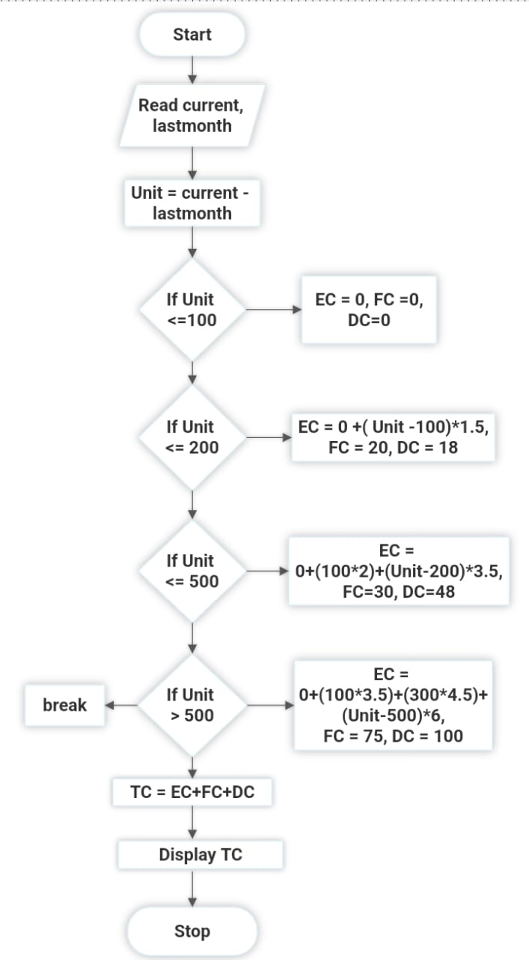

***PSEUDOCODE:***

BEGIN

READ current, lastmonth

SUBTRACT Unit = current – lastmonth

IF Unit<=100

EC = 0, FC =0, DC =0

IF Unit<=200

EC = 0+(Unit-100)*1.5, FC=20, DC=48

IF Unit<=500

EC = 0+(100*2)+(Unit-200)*3.5, FC = 30, DC = 48

IF Unit > 500

EC =0+(100*3.5)+(300*4.5)+(Unit-500)*6, FC = 75 ,DC=100

ADD TC = EC+FC+DC

DISPLAY TC

END

***RESULT:***

Thus the algorithm is written and the flowchart is drawn for the given problem.

|  |
| --- |
| EXPNO: 1B |
| DATE: 29.11.22 |

**1B) CALCULATING WEIGHT OF A STEEL ROD :**

***AIM :***

To draw flowchart and write algorithm for calculating weight of a steel rod.

***ALGORITHM :***

STEP: 1: Start.

STEP: 2: Get no of rods and Diameter of its ends.

STEP: 3: Set counter i =1.

STEP: 4: If i <= n, Otherwise Goto Step 6.

4.1: UnitWt =D^2/162

4.2: Wt = n*D*UnitWt.

4.3: Total = Total+Wt.

4.4: i = i+1.

STEP: 5: Display Total.

STEP: 6: Stop.

***FLOWCHART:***

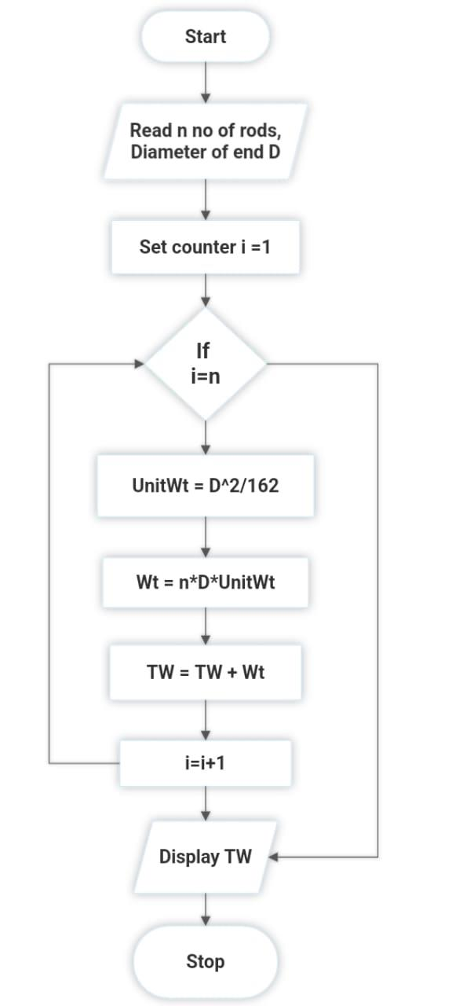

***PSEUDOCODE:***

BEGIN

READ n, d

INITIALIZE i =0

IF i <= n

THEN UnitWt = d^2/162

Wt = n*d*UnitWt

Total = Total +Wt

i = i+1

DISPLAY TW

END

***RESULT :***

Thus the Algorithm is written and Flowchart is drawn for the given program.

|  |
| --- |
| EXPNO:1C |
| DATE:29.11.22 |

**1C) CALCULATING WEIGHT OF THE MOTOR BIKE**

***AIM:***

To draw flowchart and write algorithm for calculating weight of the Motor Bike.

***ALGORITHM :***

STEP: 1: Start.

STEP: 2: Get values for GVWR, DW, FW, RW, PW,Load.

STEP: 3: TW = GVWR+DW+FW+RW+PW+Load.

STEP: 4: LoadWt = Load+TW.

STEP: 5: SafeWt = GVWR-LoadWt.

STEP: 6: if SafeWt >=0; Display “ Correct Weight, Happy Journey !”, else goto Step 7.

STEP: 7: Display “Overload, Reduce Weight”.

STEP: 8: Display Total.

STEP: 9: Stop.

***FLOWCHART:***

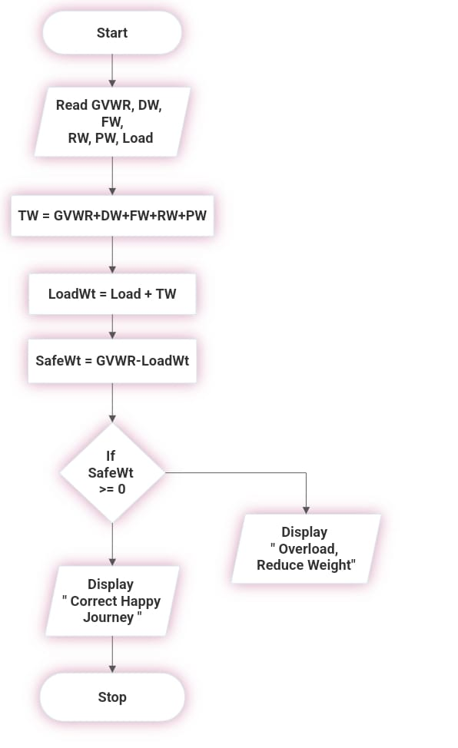

***PSEUDOCODE:***

BEGIN

READ GVWR, DW, FW, RW, PW, Load

ADD TW = GVWR+DW+FW+RW+PW

ADD LoadWt = Load+TW

SafeWt = GVWR-LoadWt

IF SafeWt >= 0

THEN DISPLAY “Happy Journey”

ELSE

DISPLAY “Overload, Reduce Weight”

END

***RESULT :***

Thus the Algorithm is written and Flowchart is drawn for the given program.

|  |
| --- |
| EXPNO:1D |
| DATE: 29.11.22 |

**1D) SINE SERIES**

***AIM:***

To draw flowchart and write algorithm for sine series.

***ALGORITHM :***

STEP: 1: Start.

STEP: 2: Read value of x,n.

STEP: 3: Set counter i = 1, sine = 0, import math.

STEP: 4: if i < n, y = x*3.14/180, Otherwise goto Step 7.

STEP: 5: sine = sine + ((y^2*i+1)/math.factorial(2*i+1))*(-1^i).

STEP: 6: i = i+1.

STEP: 7: Display sine.

STEP: 8: Stop.

***FLOWCHART:***

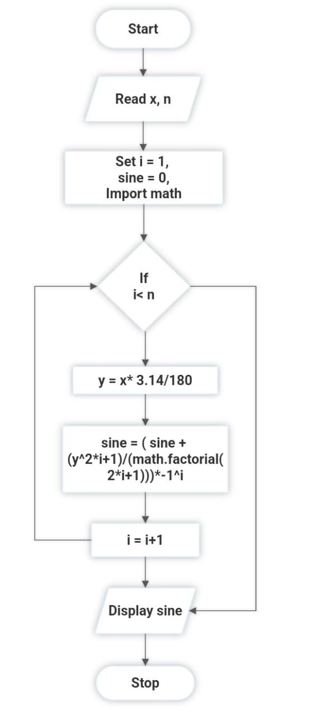

***PSEUDOCODE:***

BEGIN

READ x, n

INITIALIZE i=1, sine =0

IF i < n

THEN y = x*3.14/180

sine = (sine+(y^2*i+1)/(math.factorial(2*i+1)))*-1^i

i=i+1

DISPLAY sine

END

***RESULT :***

Thus the Algorithm is written and Flowchart is drawn for the given program.

|  |
| --- |
| EXPNO:1E |
| DATE:29.11.22 |

**1E) RETAIL SHOP BILLING**

***AIM:***

To draw flowchart and write algorithm for Retail Shop Billing.

***ALGORITHM :***

STEP: 1: Start.

STEP: 2: Read no of items n, Up, no, discount.

STEP: 3: Set counter i = 0,Total = 0,Stotal = 0.

STEP: 4: if i <= n, Stotal= no*Up, Otherwise goto Step 9.

STEP: 5: Disc = Stotal*discount/100.

STEP: 6: Total = Total +Dis.

STEP: 7: i=i+1.

STEP: 8: Display Total

STEP: 9: Stop.

***FLOWCHART:***

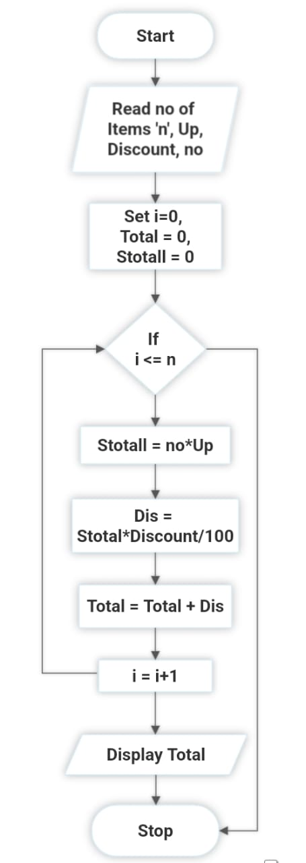

***PSEUDOCODE:***

BEGIN

READ n, Up, Discount,no

INITIALIZE i= 0, Total= 0, STotal =0

IF i<=n

THEN STotal = no*Up

Dis = STotal*Discount/100

Total = Total +Dis

i= i+1

DISPLAY Total

END

***RESULT :***

Thus the Algorithm is written and Flowchart is drawn for the given program.

|  |
| --- |
| EXPNO: 1F |
| DATE: 29.11.22 |

**1F) STUDENT GRADE ANALYSIS**

***AIM:***

To draw flowchart and write algorithm for student grade analysis.

***ALGORITHM:***

STEP : 1: Start.

STEP : 2: Read n no of students.

STEP : 3: Set counter i =0.

STEP : 4: If i<=n:

4.1: Read Total mark m.

4.2: If m>=80:

4.2.1: Display Grade A.

4.3: If m>=60:

4.3.1: Display Grade B.

4.4: If m>=53:

4.4.1: Display Grade C.

4.5: If m>=40:

4.5.1: Display Grade D.

4.6: Else Display Fail.

STEP : 5: Stop.

***FLOWCHART:***

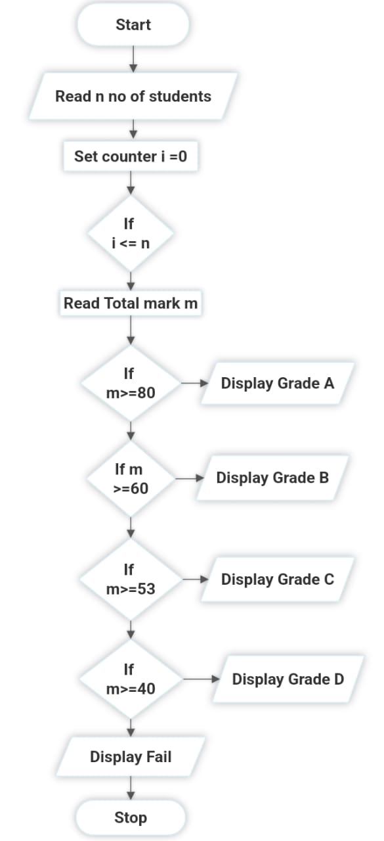

***PSEUDOCODE:***

BEGIN

READ n

INITIALIZE i=0

IF i<=n

THEN READ m

IF m>=80

DISPLAY Grade A

IF m>=60

DISPLAY Grade B

IF m>=53

DISPLAY Grade C

IF m>=40

DISPLAY Grade D

ELSE

DISPLAY Fail

END

***RESULT:***

Thus the algorithm is written and flowchart is drawn for the given program.

|  |
| --- |
| EXPNO:1G |
| DATE:29.11.22 |

**1G) ELECTRIC CURRENT IN 3 PHASE AC CIRCUIT**

***AIM:***

To draw flowchart and write algorithm for current in 3 phase AC circuit.

***ALGORITHM :***

STEP: 1: Start.

STEP: 2: Read values of Pf, I, V.

STEP: 3: Calculate P = (3)^1/2*Pf*I*V.

STEP: 4: Display P.

STEP: 5: Stop

***FLOWCHART:***

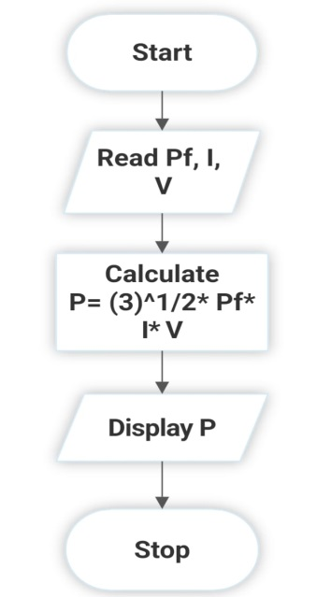

***PSEUDOCODE:***

BEGIN

READ Pf, I, V

CALCULATE P = (3)^(1/2)*Pf*I*V

DISPLAY P

END

***RESULT :***

Thus the Algorithm is written and Flowchart is drawn for the given program.